**HUMAN COMPUTER INTERACTION**

**ASSIGNMENT NO. 2**

**[CLO1, PLO1]**

**Sample Solution**

**Individual Assignment 04 MARKS**

Gestalt Principles are principles/laws of human perception that describe how humans group similar elements, recognize patterns and simplify complex images while perceiving objects.

Identify interface design or websites content which have used Gestalt principles (any 4) for organizing / structuring the website. Give snapshots and URL of the webpage (or its part) for each principle applied.

**Proximity:**

The gestalt principle of proximity explains that elements that are closer together are perceived to be more related than elements that are farther apart. When objects are close, they tend to be perceived as one group.

The first step to properly implementing the principle of proximity is understanding the importance of **white spaces** in design. It influences the relation between different elements.

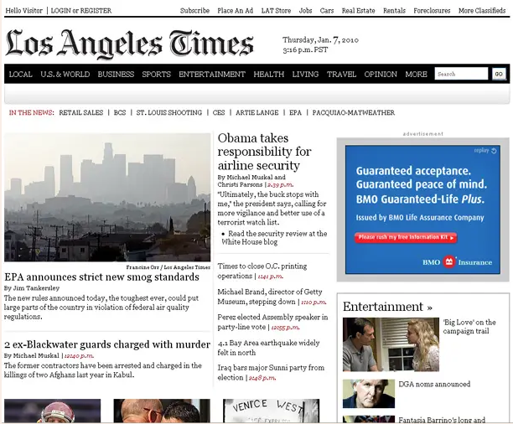

­­­­­­­­­­­­­­­­­­­­­­­­­­­­­­­­­­ LA times is the best example of proximity.

**Grid Help With Proximity:**

The grid-based content also complies with the golden rule of proximity. Grid will help to make sure that your website is not too text heavy, or overwhelming. It will also help to keep your users interested.

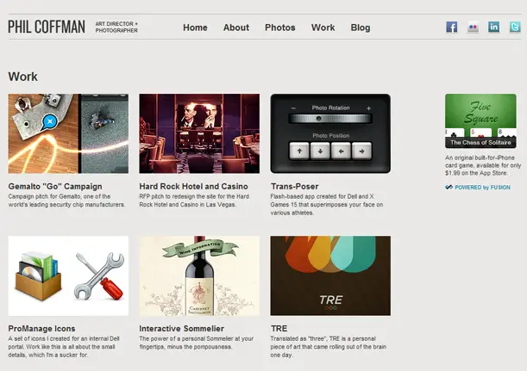

In the snapshots below, you can clearly notice how the elements of the same category are placed together to show the relation with the main menu type. The users’ eyes are automatically drawn to the subtypes under the main heading. It is as per the principle of proximity.

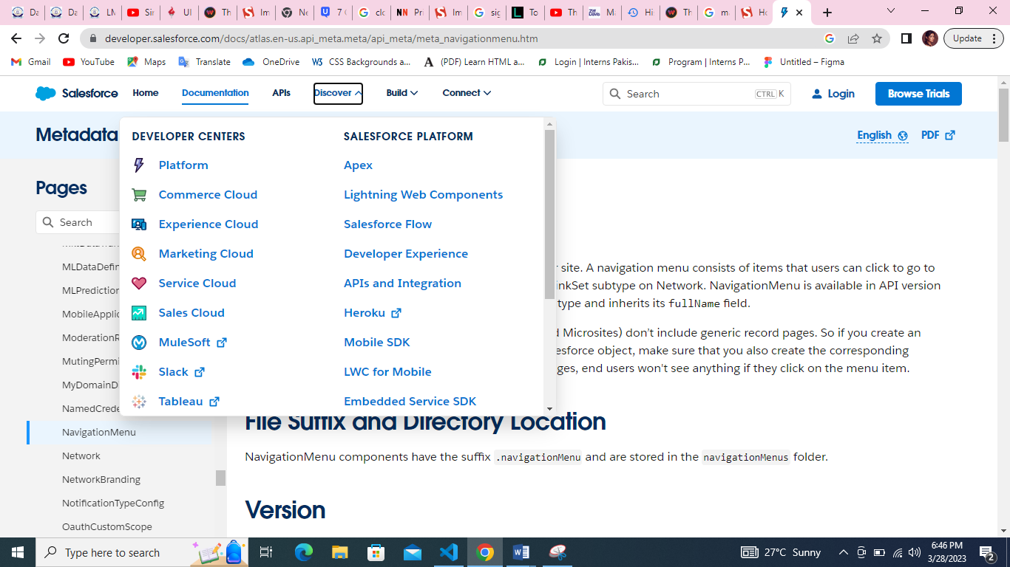

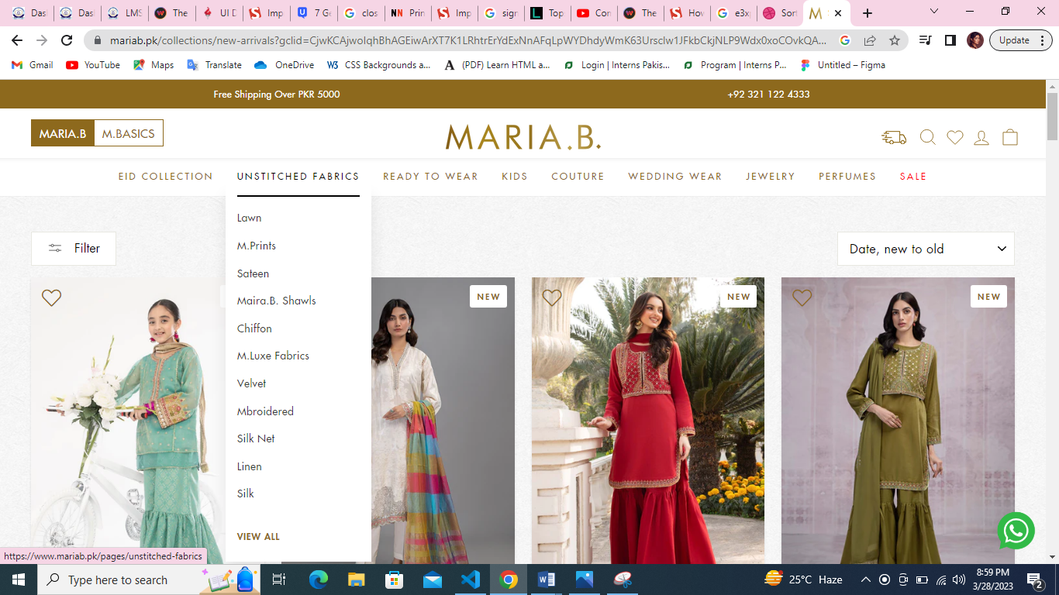

**COMMON FATE :**

When elements move in the same direction they are perceived as part of the same group by the human brain. The principle of common fate is fundamental in motion design. It state that objects that are synchronized or coordinated are likely to be grouped as one

e.g : flocks of bird, fish swim together, cars moving together down a road shows the principle of common fate well.

In UI design the common fate applies to the elements like nested menus, dropdown or accordions, it helps to bring clarity in menu options and is always applied in animation.



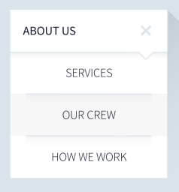

Another great example of the principle in action is seen in Peek’s calendar app. Peek uses common fate throughout the app to convey relationships between elements. For example, as seen below, when a date is tapped, content unfolds and moves down, exposing the day’s events. This movement serves to relate the events to the day selected and to focus attention on the events within.

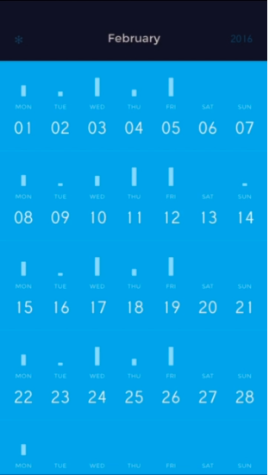 

Likewise, common fate is in action in the example below from Sana Safinaz. Here, when the **sort by** button is tapped, we see that the options move together as one, causing us to perceive them as being related elements that perform similar actions. The movement also keeps attention focused on the task at hand.

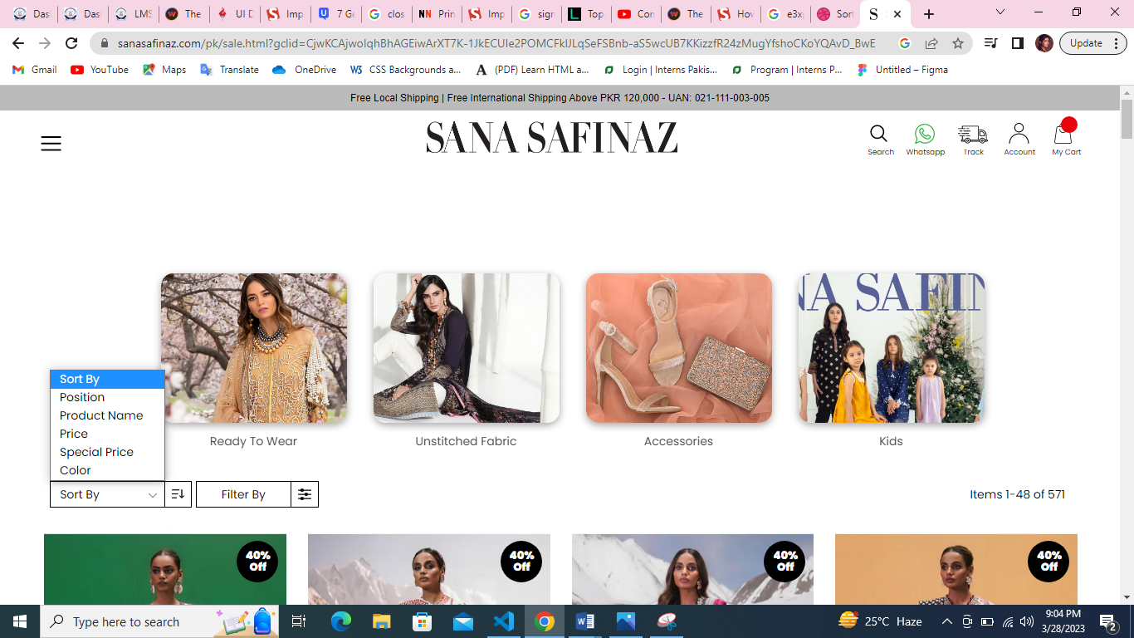

**Closure:**

The principle of closure states that when we look at a complex arrangement of visual elements, we tend to look for a single, recognizable pattern. In other words, when you see an image that has missing parts, your brain will fill in the blanks and make a complete image so you can still recognize the pattern.

The closure principle is used often in logo designs.

In the example below, our minds fill in the blanks to perceive complete shapes.



The logo for Public Broadcasting Service(PBS) applied the principle of closure to communicate 3 heads (2 in positive space and 1 in negative space)



In contrast, the Target app successfully applied the principle of closure to indicate additional page elements. The design presented 3 button options under Shop your store; the third option was cut off. This third element had approximately 40% of the size of the other two elements and supplied enough content to communicate information.

When presented with incomplete objects and information, humans have a tendency to fill in the blanks. we can apply the principle of closure to simplify visual elements and communicate (and encourage interaction with) additional information.

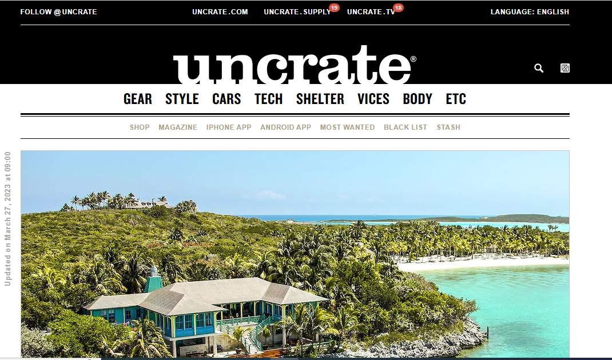

While closure is great for the creation of interesting logos, it can work in other ways as well. Websites can also use positive and negative space in the design of their interfaces to produce effective closure. Above, the [**Uncrate**](https://uncrate.com/) logo uses positive space against a black, negative background to form the letters of its logo and create the branding of the site.

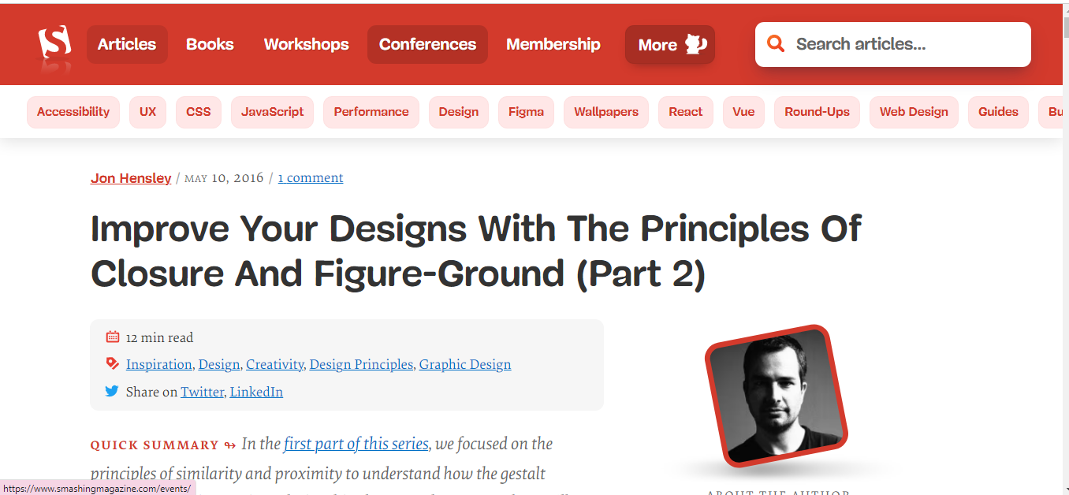

In the above example, multiple red buttons below main menu/navigation (technologies, tools name written on them ) the last button on that screen is cut off. They have applied the principle of closure to indicate additional content exist.

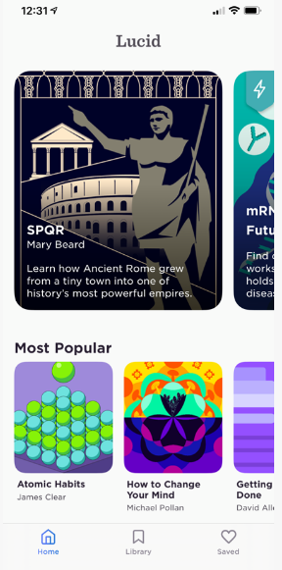

Same case applies here in above image. Designers use the principle of closure to indicate that additional content exists, encourage interaction with said content.

Many [**carousel**](https://www.nngroup.com/articles/mobile-carousels/) designs take advantage of the principle of closure when they show only parts of an item in the carousel.

**Continuation:**



Input boxes in a form are all left aligned on the same grid line. By doing this we are creating continuity between each individual form field. This allow a user to quickly and easily navigate the form without disruption.

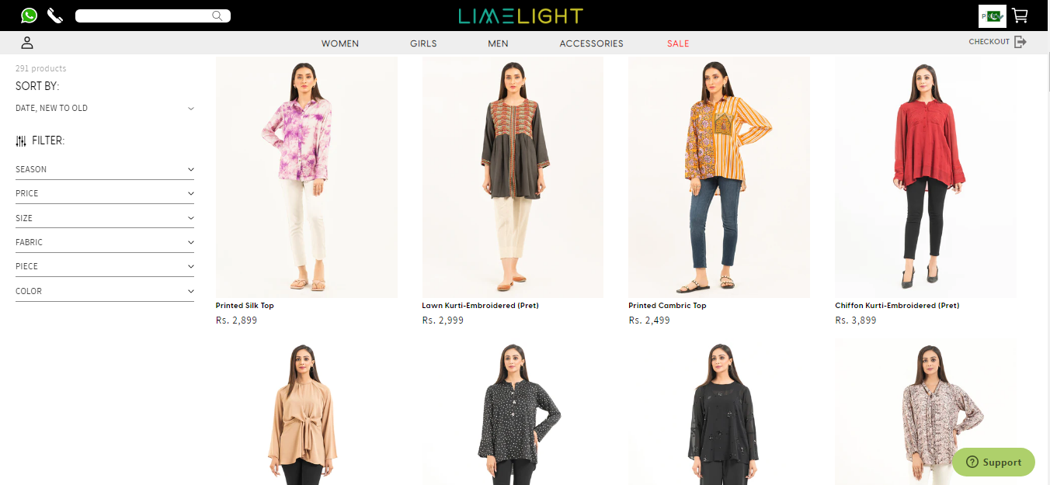

Photos of items user is browsing are aligned on a column grid and draws user eye down the page .so you can easily view more items.

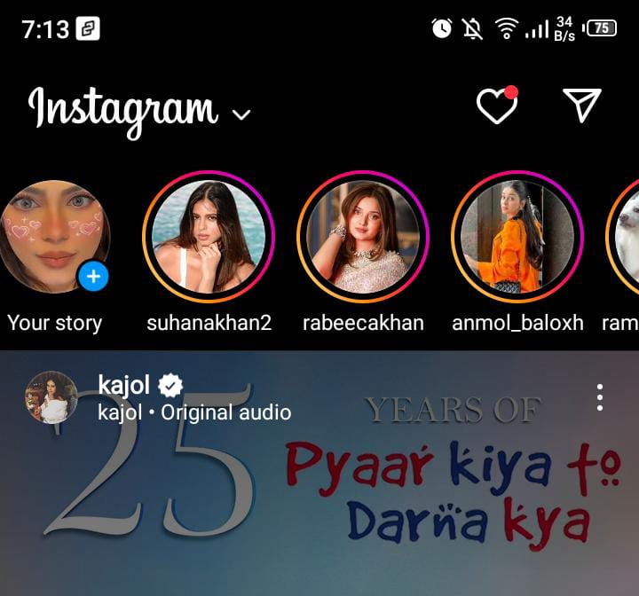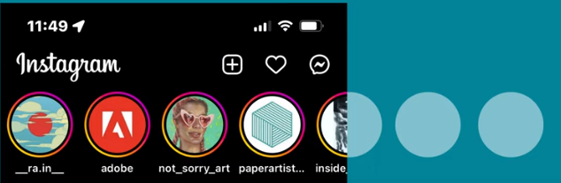

Social media also employs the use of continuation. For instance, the Instagram stories on your feed continues even one of the circle is cut off. Our brains are able to fill in that path continues and that there will be more content available.

It’s important to use continuation throughout your design. that way people can easily navigate through your interface effectively and without interruption.

_____________________________________________